Design Document for:

Little Robot’s Adventure

Developed by students at: “The Ohio State University”

All work Copyright ©2009 by: OgreNoName

Written by: Hiroshi Hayashi, Bryan Linthicum, Brett Kizer

Version: 1.0

Tuesday, June 9, 2009
Table of Contents

Little robot's adventure 1
Design History 4
Version 0.10 4
Version 0.20 4
Version 0.30 4
Version 0.40 4
Version 1.00 5
Game Overview 6
Philosophy 6
Impreovments of a Classic 6
3D Environment 6
AI Design 6
Storyline 6
goal (win state) 6
Game Modes and Controls 7
What can the user control in - Level editing Mode? 7
What can the user control in - Game play Mode? 7
Frequently Asked Questions 7
Why create this game? 7
What makes this game different? 7
What is the goal of the game? 7
Are there any NPCs in the game? 7
Are there any Skills or Items in the game? 7
Feature Set 8
General Features 8
Level Editor Features 8
Game play Features 8
The Game World 9
The Physical World 9
Time 9
Scale 9
Dynamic Lighting and Sky 9
Rendering System 9
2D GUI and Overlays 9
3D Environment 9
OpenGL and DirectX 9
Game Characters 10
The Player 10
Enemies 10
Melee Ogres 10
Ranged Ogres 10
Melee Ninjas 10
Weapons / Skills 10
Close Range 10
Long Range 10

User Interface (GUI) 11
Level editor GUI 11
Title Bar 11
Dropdown menu 11
3D model viewer 11
Menu options 11
Game play GUI 12
Health and Skill bar 12
Menu options 12
3rd party game engines 13
"MOC" Collision Detetion Engine 13
"FMOD" Audio Engine 13
"Artifex Terra" Terrain Editor 13
"CELayoutEditor" GUI Editor 13
"Prticle Editor" from Ogre3D 13
Game architecture design 14
figure 1 - game state design 14
entity manager 15
overview 15
class hierarchy 15
figure 2 - entity manager / factory 16
figure 3 - entity hierarchy 17
Music Scores and Sound Effects 18
Overview 18
Music Composition 18
3D Sounds 18
Sound Manager Design 18
figure 4 - sound manager 17

Design History:

Version 0.10
The goal for this release was to get our group members familiar with the Ogre3D and CEGUI libraries to begin game designs. At the time, our various game states were in their infancy and not designed properly. The first installment of our project was a very rough mockup which presented a starting (loading) screen with the university logo and various development tools used. The program then transitioned to the main menu screen with several options. However, none of the buttons actually worked when pressed.

Version 0.20
The goal of the second release was to fully integrate the game state design concept seamlessly into our project. Other goals were to implement basic object collision detection, audio capabilities, data-file and script-file driven coding, as well as basic interaction capabilities. We were able to achieve all but the last goal for this edition of the release. Instead, we designed a “Level Editor” where the user could interact with a GUI; able to place various objects on a terrain map and save the model locations for later use. Although the feature to save was implemented with a file created, we did not have the implementation completed to “Load” the data file into a terrain map of the user’s choosing.

Version 0.30
The goal of the third release was to get a finish layout of all GUI systems for the game. This included the main menu, level editor, and game play states. Another major achievement was a fully function console system, where user commands could create entities, change variables, and other scriptable parameters for the game. One of the last features incorporated into the release was a basic AI for enemy entities. With all of this came the first finished map (level) for the user to play the game with.

Version 0.40
The goal of the fourth release was to begin incorporating particle systems for special effects in the game play, and create an Entity manager to deal with all objects within the game. We also began incorporating more complex GUI systems and interactive game features, such as displaying entity properties when selected. The biggest milestone was the completion of the Entity manager. This allowed our team to create any number of entities for the game, and tie it into the existing console system to create new entities for testing. For the level editor, we were able to load a map with its various entities from a hard-coded file name. Lastly, basic collision detection between player and world was implemented.

Version 1.00
The final release had a whole list of minor and major features which needed to be completed. Below is a bullet list of features which were completed for this release, based on categories:
Main Menu:
- Completed the ability to Load a pre-made map for game play.
- Completed the ability to change system properties, such as screen resolution, from the options menu.
Level Editor:
- Completed ability to Load/Save to any file name the user wanted
- Created a safety measure to request overwrite of an existing file.
Particle System:
- Completed particle effects for in-game spells and attacks, such as: Healing, Fireball, Bullets, etc.
- Completed particle effects for the environment, such as Fire.
Sound Effects:
- Attached sounds to necessary actions, and background music to all major game states.
- Fixed glitches between state transitions, where all sound channels for that state needed to be reset
Entity Manager:
- Create more enemy types with various attack styles, attack speeds, and fault tolerances.
- Completed the ability to create any number of NPCs, and call them by ‘Name’ rather than number.
- Polished the player’s attributes, such as skill options, damage rates, etc.
Artificial Intelligence:
- Completed a more robust AI system for enemies to follow.
- Varying degrees of AI based on enemy type.
Physics:
- Polished the collision detection between player and entities, and other entities with other objects.
- Improved bullet physics of basic player attack, projectile spells, and enemy projectiles.
Game play:
- Completed the Mini-map GUI, where the player location is updated, and displays all entities on the map.
- Completed the Skills GUI, where certain skills are disabled, or invisible until they become available.
- Completed the entity status GUI, where selected object HP (health) values might change.
- Completed the NPCs, where each one displays a GUI, presenting the user with more of the game storyline.
- Polished the collision detection between player and entities, and other entities with other objects.
Game Overview:

Philosophy

Improvements of a Classic:
The goal of this game was to recreate an old 1999 PC Role Playing Game (RPG) designed by Blizzard Entertainment called Diablo II. Diablo II was a 2D isometric designed game. However, our team wanted to create a 3D version of the game with a movable 3rd person chase camera. Since we were on a 10-week project timeframe, we decided not to implement any form of inventory system. We focused mainly on game play, and several linear designed maps in which the user would play to reach the final boss or battle.

3D Environment:
Most games designed today are designed in 3D space. The challenges associated this is an extra Y vertical axis in which objects must be clamped to the surface based on its height. The use of height maps is required to achieve a 3D looking map, as well as the ability to calculate current terrain height. Another challenge to a 3D environment is the camera. Unlike a static 2D camera, the user must have the ability to swivel the camera in any direction around a fixed point in 3D space.

AI Design:
Most people think of Game AI as just being mob (enemy) intelligence. However, this also includes:
Terrain path finding, line-of-sight aiming, fault tolerance, flocking (swarming), and various heuristic algorithms used to improve search times in various search spaces. The game must also implement AI intelligence in a way such that as the game progresses, the enemy AI must become “smarter” and more difficult to defeat.

Storyline
The world is being terrorized by a large swarm of monsters, and someone must stand up against them. The user must fight against various enemies, and fight his/her way to the final battle. Instead of fighting a “Final Boss”, which is one extremely powerful enemy, the player must fight against a large group of them. In this game, the final battle will be to destroy all enemies at their fortress.
As the game progresses, enemy types will change and become strong. The user must interact with NPCs on the map to determine where to go next. Each NPC tells a little more about the story behind the game.

Goal (Win State)
The goal of this game is to rid ALL enemies from the player’s world without dying.

Game Modes and Controls

What can the user control in – Level editing mode?
In the Level Editor, the user can move the camera using the A/S/D/W and Arrow-keys to move the camera. Camera rotation can be done by holding the Right mouse button and dragging. Object placement and world interaction is controlled by the Left mouse button and selecting items from the GUI dropdown menus.

What can the user control in – Game play mode?
During game play, the user can use the A/S/D/W and Arrow-keys to move the player. The camera follows the user, and camera rotation is done by holding the Right mouse button and dragging. Attacking an enemy is done by a single Left click on the enemy mob in question.

Frequently Asked Questions

Why create this game?
All of our group members have a passion for Role Playing type games and decided to take the challenge to create a miniature version. It was also a great opportunity for us to learn more about game design and philosophy.

What makes this game different?
Unlike most RPG type games which have static level which are always the same, our game features the ability for the user to create his/her own level. The ability to place any object in desired locations makes the game more interesting.

What is the goal of the game?
To defeat the final boss (enemy) that is terrorizing the game world.

Are there any NPCs in the game?
Yes, there are various NPCs which tell you what is going on in the world. However, none of the NPCs will be selling items, since there is no inventory system in the game.

Are there any Skills or Items in the game?
The only skill given to the player is a Recovery skill. Based on the elapsed time, the user can use the skill again. There will not be any items, because there is no inventory system implemented.
Feature Sets:

General Features
- 3D environment
  - Dynamic paged terrain system (load only necessary sections of the terrain into memory)
  - Realistic water and refraction effects
  - Dynamic skybox and lighting system (ie. Morning, afternoon, evening, and night cycle system)
- 3D sounds with 5.1 surround sound capabilities
- Camera controls
- Level editor Mode
- Game play Mode

Level Editor Features
- Camera movement and rotation
- Background music during development
- Placement of Audio sounds
- Placement of world objects (ie. Trees, houses, etc.)
- Placement of enemy Mobs
- Placement of player Starting and Goal points

Game play Features
- Player movements
- 3rd person chase camera
  - Camera rotation
- Changing background music based on current level
- Dynamic sky and lighting system (ie. Day/Night system)
- Interactions with NPCs
  - NPCs only tell the story of the game
  - Cannot buy any items from them
- No inventory system
- Recovery skill to increase player health over time

The Game World:

The Physical World

Time:
The game is real-time and player/enemy interaction must be dealt with accordingly.

Scale:
The world scaled is mainly based around buildings and terrain sizes. All other models in the world (ie. trees, players, enemies, bridges, etc) are ball scaled accordingly to represent realistic world scaling.

Dynamic Lighting and Sky:
The game has a dynamic skybox and lighting system, in which it simulates the Day and Night cycles. The ambient and directly light simulated from the sun will change in intensity and color based on the time of day (ie. Sunset has a redish environment color). During the night cycle, the moon will light the world, and the skybox will have stars to simulate a night environment.

Rendering System

2D GUI and Overlays:
All GUIs are created using CEGUI and the Overlay setting is enabled where the Z-buffer is disabled to render all items on the screen in 2D space. Once all rendering is completed, the Overlay setting is disabled to return to 3D rendering. The Introduction and Credit graphics are done by drawing 2D rectangles, applying a material texture (image) to it, and changing the alpha values to give the fading effects.

3D Environment:
All other graphics (ie. Terrain, player, enemies, etc) are rendered using 3D graphics. Mesh files represent the model shape, and skeletons are used to manipulate movable object joints to simulate movement animation.

OpenGL and DirectX:
The game supports both OpenGL and Direct3D rendering engines. The user can make the adjustments in the options menu. This allows for the game to be played across multiple platforms.

Game Characters:

The Player
The user is only allowed one character type to play. It is a robot, which can fire bullets at the enemy. As the enemy progresses through the game and gains levels, it will gain special abilities, such as protection spells and projectile spells.

Enemies
There are several enemy types the player will have to fight against.

- Melee Ogres
  - These are the basic enemies. The are large and pack quite a punch when they hit you. The best tactic against them is to fire your main weapon, then flee backwards to evade their swings.
- Ranged Ogres
  - These Ogres are smaller than the Melee ogres, but have powerful ranged shots. The Ranged Ogre’s range is quite far, so rapid shooting against them is the best tactic. Kill them before they deal too much damage.
- Melee Ninjas
  - These are harder to kill compared to the other two enemy types. Ninjas have more HP (health), but they also move very fast. Running from these enemies will not work, so it is best to FIRST shoot at them from a distance, then rapid fire at them.

Weapons / Skills:

Close Range
Close range combat is almost never used by the player. The last skill the player receives in game is very powerful, but has a very short range. This skill will attack all enemies within range.

Long Range
The player’s basic attack is a ranged bullet. Two other skills the player receives within the game (Fireball and Ice Shot) are also long ranged. With this arsenal of weapons and skills, the player’s ability to win the game is much easier. The player will also receive a Heal and Barrier spell, where the barrier spell will reduce damage received.

User Interface (GUI):

Level editor GUI
The user will use this GUI to place objects on a terrain to create various maps to play from. Below is a list of various sections of the GUI the user can interact with:

- Title Bar:
  - By Left-click and dragging the top of the GUI, the user can move the entire editor GUI.
- Dropdown Menu:
  - By Left-clicking the \/ arrow box, the user may select the various objects to place on the map.
    - Selection Tool:
      - Allows the user to select any items on the screen and manipulate or move it.
    - Player Starting / Goal points:
      - Determines the starting and ending locations of a level.
    - Sounds:
      - A speaker sprite will display where the sound node is. The user may select a wide range of sounds used in the game.

    - World Objects:
      - The user can select from Trees, Houses, etc.
    - Enemy Objects:
      - The user can select and place any enemy on the map. There will be a special GUI box displaying the level of the enemy. The user can choose what level the enemy unit will be.

- Model Viewing Window:
  - Displays a 3D model of what the player has selected before placing on the world map.
- Menu Button:
  - If pressed, displays another GUI window with more menu options to select from.
    - Start New Map
    - Load Existing Map
    - Save Current Map
    - Continue editing
    - Quit to Main Menu
    - Quit Game

Game play GUI
The player will be shown a Red health bar, a Blue spell recharge bar, and an Orange experience bar. If the Red health bar reaches 0, will player will die and lose the game. The Blue spell bar allows the user to see if he/she can use a special skill. There are 5 skills, and each skill requires a certain amount of magic points. As the player kills enemies, the experience bar will increase. Once a player levels up, he/she will unlock a new magic skill to use.
For the Skills interface, same area as the 3 colors bars, the user can see which skills are available. At lower levels, certain skills cannot be used, nor are they visible. As available skills are unlocked, if they cannot be used, they will be dimmed out. Once they become usable, they will be highlighted until used.
Another GUI for the game play is the Mini-map. The player is indicated by a Red dot, which updates whenever the player moves. A Blue dot on the screen indicates NPC locations on the map. As the story progresses, the NPCs will tell the player which way to go on the map, and the player can use the dots on the screen to see where to go to find a specific NPC.
Lastly, pressing the F10 button will display a generic options menu for the game play state. The user will
have the options to: Continue, Return to main menu, or Quit the game.

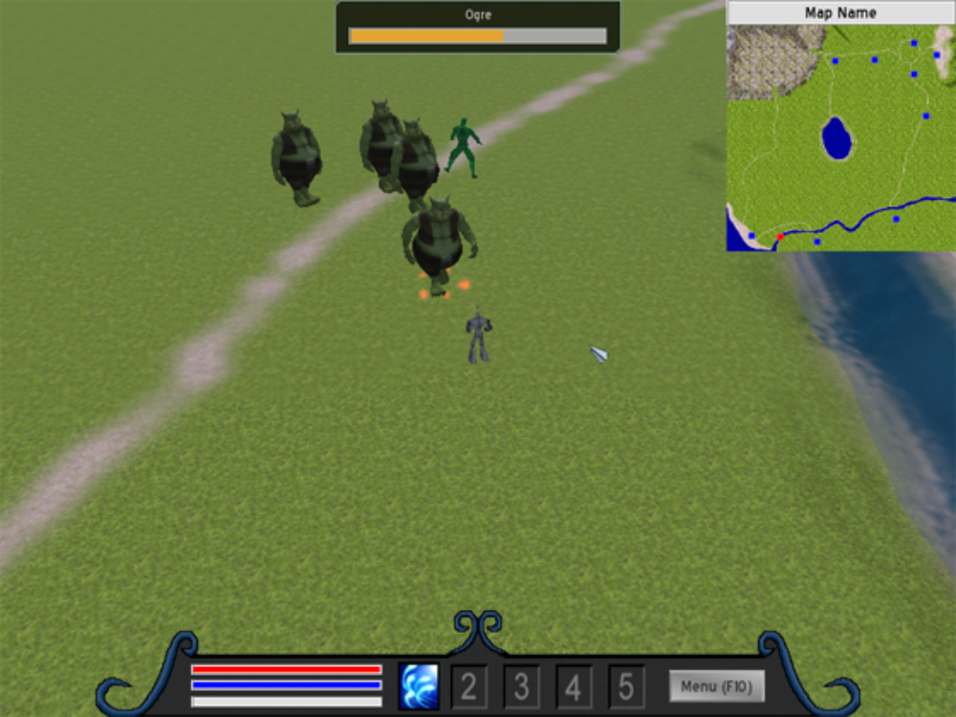
Figure 0 – Game play Screenshot
3rd Party Game Engines:

“MOC” – Collision Detected Engine:
The MOC engine, is a simple collision detection between entity to terrain, and entity to entity. Instead of checking collision between 2 objects manually, the MOC engine keeps track of all entities and updates their collisions whenever necessary.

“FMOD” – Audio Engine:
The FMOD audio engine is a commercial audio library that is used for the creation and playback of interactive audio. FMOD is widely used in the video game industry and is known for its ease of use as well as its cross-platform support. The engine supports many platforms including the PC and the ‘next-gen’ video game consoles, and it also supports a wide range of audio formats. FMOD is free of charge for use in non-commercial applications.

“Artifex Terra” – Terrain Editor:
Artifex is an excellent way to edit terrains. Based on how the terrain mesh looks like, a height map is auto generated for the user. Also, the user can “paint” various textures to the terrain within the editor. The editor will create the necessary image files (material files) to apply to the terrain mesh file. The editor also allows the placement of entity models, such as: Trees, Rocks, Towers, Bridges, etc.

“CELayoutEditor” – GUI Layout Editor:
This is a useful tool, for the user to see before hand what a GUI looks like. Crazy Eddites (CE) uses XML scripting to create a GUI. Without the editor, the user must test the GUI in-game, or try to visualize it beforehand. With the editor, this allows GUI modifications faster and easier. Basically, a (.layout / .scheme / .imageset) files are required to create a single GUI. Editing by hand can still be done.

“Particle Editor” – from Ogre3D:
This is a 3rd party tool, which allows a user to easily customize particle effects. The data is written to a file, then the particle engine parses the scripted file to generate particle animations.
Game Design Architecture:
Below is a diagram of the Game States architecture for the program. When the program executes, it starts in the Intro state, then moves to the Main Menu state. From there, the user can transition between 4 other states, 3 of which can return to the Menu state.

Intro
Main Menu
Gameplay State
Finished loading
Credit
Exit
Level Editor
Select ‘New’ or ‘Load’ Game
Select ‘Level
Editor’
Select ‘Return to Main Menu’
Select ‘Credits’
Select ‘Quit Game’
Automatically return to Menu upon completion
Select ‘Quit to
Main Menu’
Select ‘Quit Game’

Figure 1 – Game State Diagram
Entity Manager:

Overview
The reason for the Entity system being required by our game is because of the sheer number and complexity of entities in the game. The Entity manager’s main job is to manage how each entity behaves with each other, or as individuals. If an entity is in a “think()” state, it will determine what to do next, based on what the entity manager says.
When an entity is created, it is put on a stack with similar entity types. When an entity is created / destroyed, it is either pushed or popped off the stack. The one creating the actually entity is the Entity Factory, which is encapsulated by the Entity Manager.

Class Hierarchy
Each entity within the game inherits from a Base class. The base class allows the creation of other sub-classes, such as: Monsters, Players, Projectiles, and non-movable objects (i.e. Trees, Buildings, etc). Allowing this kind of design not only makes it more organized, but more abstract. Because the entities are moiré abstract, less data processing is required to process a single entity. This allows for faster object handling and performance.
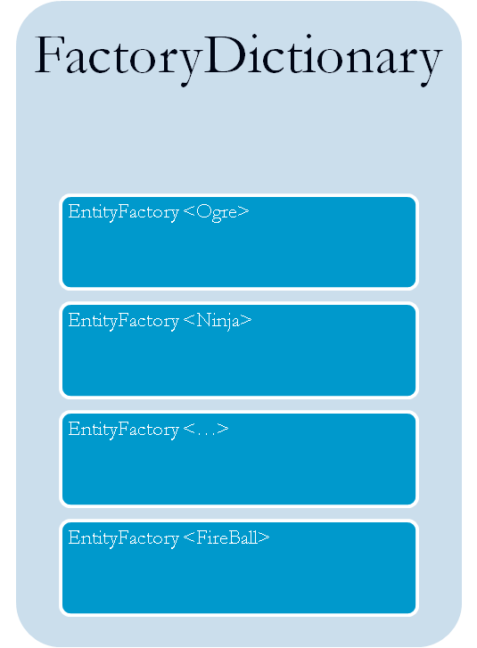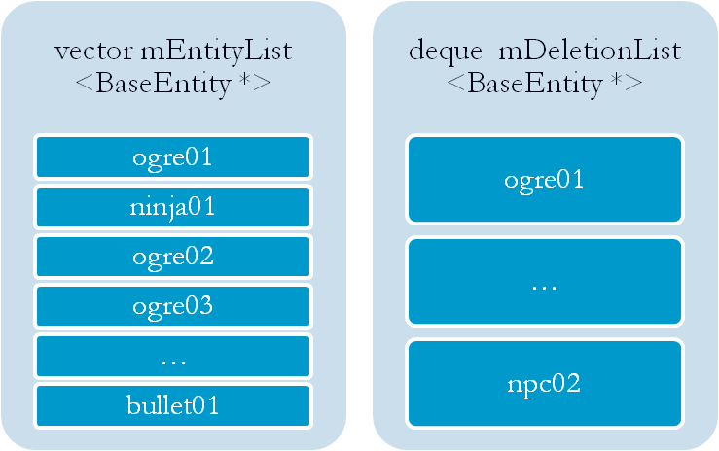
EntityManager
installFactory (factoryType t)
findFactory (string ClassName)
createEntity (string ClassName)
Map <string, EntityFactory>:
Create ()
Destroy ()
Create ()
Destroy ()
Create ()
Destroy ()
Create ()
Destroy ()
Create (string className)
Destroy (BaseEntity* e)
Figure 2 – Entity Manager / Factory
BaseEntity
Scene Node
Velocity
3D Mesh
Monster
Projectile
Health
Speed
AI State
Particle Effect
Speed
Bullet
Flame
FrostBolt
FireBall
Player
Ogre
EliteOgre
Ninja
NPC
attack()
die()
fire()
think()
spawn()
Figure 3 – Entity Hierarchy
Music Scores and Sound Effects:

Overview
There will be three main types of music and sound effects present in the game: background music, environmental/ambient sounds, and sound effects when the player interacts with the environment and enemies. The background music will be playing throughout the single player campaign as well as when the player is using the level editor. The environmental sounds will be 3D positional sounds (discussed below) and will include water flowing, birds chirping, and other ambient noises. The sound effects will include weapon interactions during fights, grunts when enemies die, and many others.

Music Composition
All background music was used from other professionally developed games. Most of the musical scores chosen came from free MMORPG games which can be downloaded online. Any of the musical scores chosen which did not come from a free MMORPG came from a soundtrack which a group member owns. The audio track was ripped and encoded into .mp3 files for easy playback.

3D Sounds
3D sounds attempt to widen the stereo image produced by two speakers or stereo headphones and to create the illusion of sound sources placed anywhere in three dimensional space, including behind, above or below the listener. 3D sound is very similar to 2D sound, but with 3D sound the volume changes based on the listener’s position. All environmental sounds and sound effects in the game will be 3D sounds.

Sound Manager Design
The Sound Manager class is a framework that utilizes the FMOD audio library to integrate sounds and music into an Ogre application. Sound Manager takes the functionality of the FMOD library and makes it easy to create sounds (looped or un-looped, 3D or 2D), play sounds, change the volume, etc. using simple function calls. Sound Manager was designed for use with the OGRE 3D Graphics Engine and is used to control all of the audio in the game.
This is an abstract view of the Sound Manager architecture. Whenever a sound is created by the manager, it creates a sound Node with various channels attached beneath it. The sound channels control the volume, direction, and other properties of the sound

SoundManager Instance
Sound1
Channel1
………
Sound2
Channel3
Channel2
Channel4
………
…………………........
CreateSound()
CreateSound()
PlaySound()
PlaySound()

Figure 4 – Sound Manager

